Adding Documents to an Application
This document is designed to explain the process for adding documents to an application in RSS.

- On the left menu of the application, click “ADD DOCUMENT”.
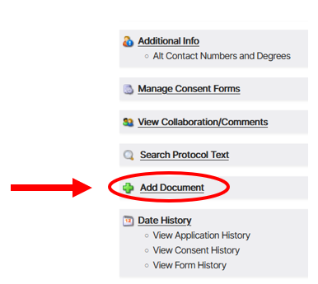

- A separate window will pop up. DRAG AND DROP or click BROWSE to add documents.
Note: Up to 5 documents may be uploaded at a time.

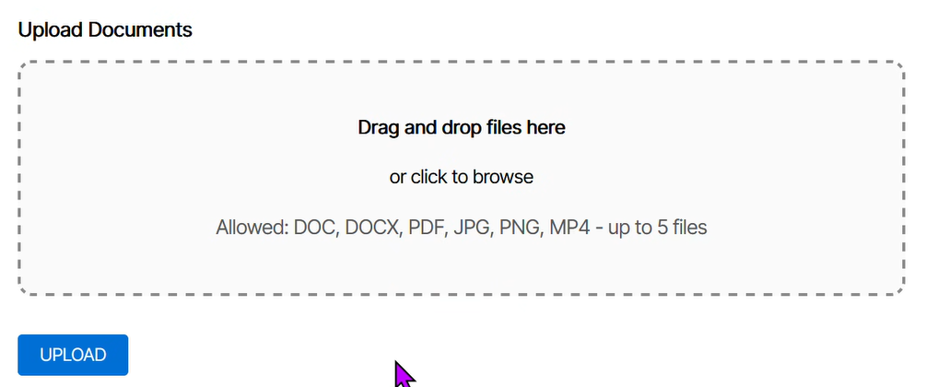

- Documents must be given a description.
Note: The description name should be as short as possible but clearly identify the document (e.g., flyer, protocol, main consent, NIH grant).

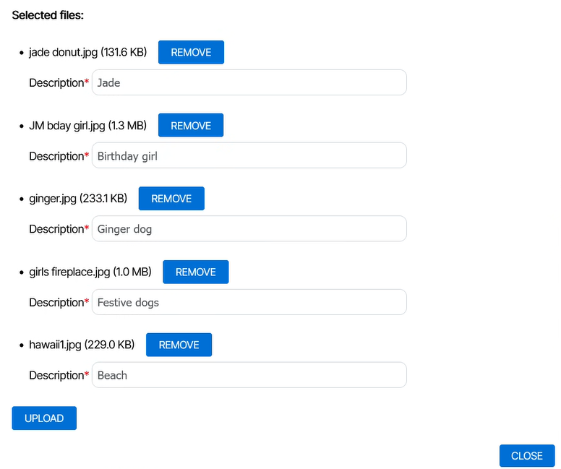

- Click “UPLOAD”.
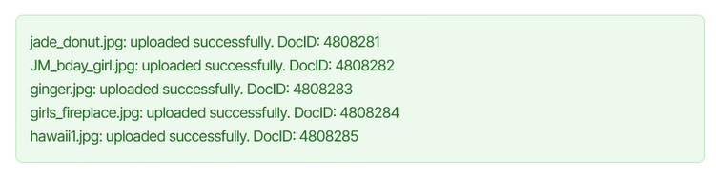
- Repeat until all documents are uploaded, then click “CLOSE”.

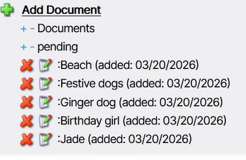
- Uploaded documents will display in the “pending” folder” under “Add Documents” in left menu of your application.

Note: Documents with a red ‘x’can be deleted. To delete a document, click the red ‘x’. If the document does not have a red ‘x’ and you need it removed, please send a message in the message portal of the application.

