Single IRB (sIRB) Research

The following document will guide you on the Organization’s requirements when the UNMC IRB is serving as the sIRB for multi-site research. Click here to review the full UNMC HRPP Policy 1.3.

UNMC Lead PI Responsibilities:
The lead PI acts as the main person in charge of the entire study across all sites. They are responsible for:
- Being the main contact for the UNMC IRB and for sharing all IRB decisions with the other sites
- Answering questions from participating sites and keeping everyone informed
- Making sure participating site investigators have access to required policies (i.e. HRPP policies)
- Developing a consent form template for participating sites to use
- Sending IRB-approved study documents to the participating sites
- Promptly reporting major problems or complaints to all participating sites
- Making sure each site submits their Continuing Review application on time
- Informing sites of any lapse in IRB approval and what to do about it
- Following all other responsibilities of a PI as outlined in HRPP Policy 1.26

Procedures for Using UNMC as the Single IRB:
- Submit a Request
  - Fill out the sIRB request form in RSS.
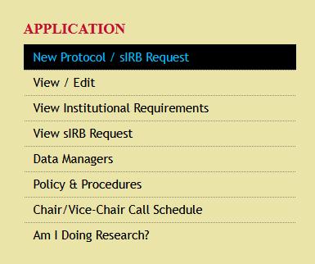
- UNMC Must Accept Single IRB Request
  - The UNMC ORA must determine whether UNMC’s IRB will act as the single IRB
- Lead PI Submits the IRB Application/Change Request
  - For new studies: the lead site fills out and submits the appropriate IRB application in RSS; or
  - For existing studies converting to sIRB: the lead site fills out and submits a Change Request in RSS to include the sIRB details (i.e. sites and personnel)
    - NOTE: The lead site will need to revise the already existing informed consent form and application to reflect the multisite nature of the study (e.g. removing site-specific language)
NOTE: you will need contact information for the PI, coordinator, and institutional official/IRB for each site
- IRB Reviews the Study/Change
  - For new studies: UNMC’s IRB reviews the research either through a full board review or expedited review, depending on study type (the type of review is determined by the assigned IRB analyst)
  - For existing studies converting to sIRB: UNMC’s IRB reviews the submitted change request
- Upon UNMC IRB Approval:
  - The UNMC IRB will invite participating sites to RSS. The invitation will be followed with instructions on how to access RSS.
  - The lead study team should be prepared to assist sites with their submission
- Participating Sites Submit a pSite Application
  - Participating sites submit a pSite application in RSS
    - Each participating site develops their site consent based on the lead site’s consent form template. Each site adds to the consent form template their own local information (e.g. contact details, compensation details, etc.) and submits it to the UNMC IRB via RSS for final approval
  - The UNMC IRB will send the Reliance Agreement to the participating sites
- Sign a Reliance Agreement (required for non-exempt research)
  - This formal agreement must be signed by all participating institutions and spells out who is responsible for what
- Follow the Right Policies
  - All sites must comply with UNMC HRPP Policy 1.3

